Barnsbury Housing Association
Board of Management
May 21, 2026
Complaints report 2025-26
Review of Complaints, Service Requests, Cllr Enquiries, Compliments and Subject Access Requests

In line with the Housing Ombudsman Complaint Handling Code, BHA undertakes an annual review of complaints to provide assurance on fairness, timeliness, learning, and compliance. This report summarises complaint performance across all stages, identifies themes and trends, and sets out how learning from complaints is used to support continuous service improvement and regulatory compliance.

The report also includes an overview of compliments received, service requests, Councillor enquiries, and Subject Access Requests, providing a broader picture of tenant contact and demand. Collectively, this information supports Board assurance that BHA is meeting its obligations under the Consumer Standards, particularly in relation to effective complaint handling, transparency, tenant engagement, and accountability.

 | Resolution | Complaints outcome
 | Resolution | Upheld | Partially upheld | Not upheld
New complaints in year | 20
Resolved at Stage 1 | 11 | 3 | 12 | 5
Progressed to Stage 2 | 9 | 1 | 4 | 4
Progressed to HOS | 3 | - | - | -
HOS cases closed | 0
 |  | 4 | 16 | 9

Stage 1 - Complaint Breakdown

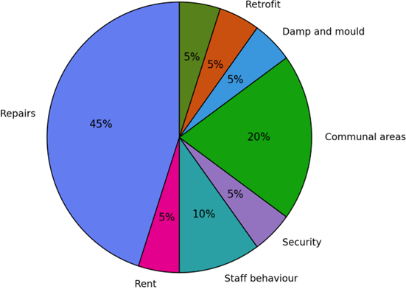

Stage 2 - Complaint Breakdown
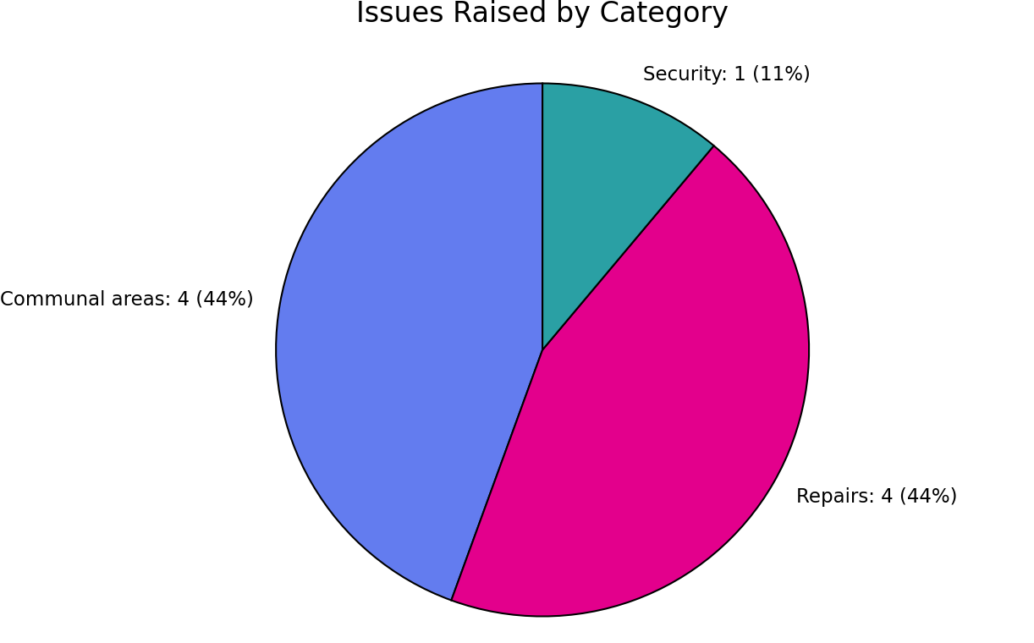

Housing Ombudsman - Complaint Breakdown
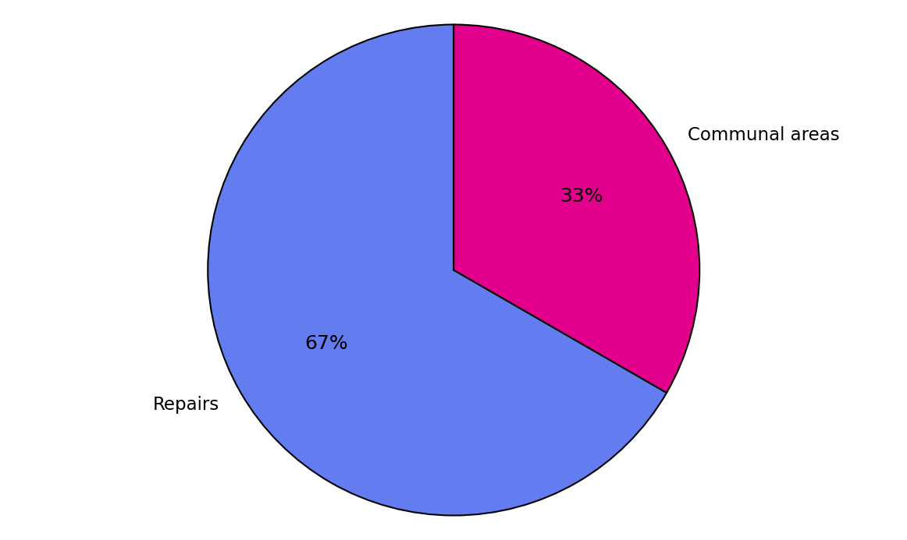

Housing Ombudsman Cases –Overview
Three complaints have been referred to the Housing Ombudsman and all remain open and under investigation at the time of reporting. BHA has complied fully with the requirements of the Housing Ombudsman Complaint Handling Code, including the timely submission of all requested evidence and documentation.
Case Summaries
Case 1: Historical Incidents and Allegations of Discrimination
The complaint relates to long-standing neighbour disputes, although these matters were addressed during 2024/25, the resident continued to raise concerns and alleged discrimination by BHA on the basis of heritage. The allegations were not upheld at either Stage 1 or Stage 2 of the complaints process. The case is currently awaiting determination by the Housing Ombudsman.
Case 2: Access to Communal Bin Store
The resident reported difficulties accessing the communal bin store due to a disability. BHA worked collaboratively with the resident over time to agree and implement reasonable adjustments, which enabled improved access. While access improvements were confirmed, the resident remained dissatisfied. This complaint was upheld at Stage 1 and partially upheld at Stage 2 and is currently under consideration by the Housing Ombudsman.

Case 3: Reasonable Adjustments to Communal Areas and Request for non landlord equipment
The resident requested adjustments to communal lighting to accommodate a disability. These works were completed within agreed timescales. Further adjustments were subsequently requested, along with a request for BHA to purchase an air purifier to address cooking odours from neighbouring properties. The request for an air purifier was declined. The complaint was not upheld at either Stage 1 or Stage 2 and is currently awaiting determination by the Housing Ombudsman.
Risk:
There is a potential regulatory and reputational risk should the Housing Ombudsman identify service failure or procedural non-compliance arising from the open investigations.
Mitigation:
BHA has mitigated this risk through full compliance with the Complaint Handling Code, timely submission of evidence, and demonstrable adherence to policy and statutory landlord duties. Robust record-keeping, clear decision-making, and the provision of reasonable adjustments where appropriate provide strong assurance. Ongoing monitoring of complaints themes and escalation trends continues to inform service oversight and risk management.
Trends of Complaints
Out of the 20 complaints, and aside from complaints being made by one tenant, we received 6 complaints relating to the repair service delivery, which included missed appointments, delays in completing works, and insufficient communication with tenants regarding repair progress. These complaints did not identify any trends relating to blocks, schemes or estates nor did they reflect any patterns related to complainants’ protected characteristics.
Our Stage 1 complaints are predominantly driven by issues linked to the Safety & Quality Consumer Standard, which account for over half of all complaint themes (11 of 20), largely relating to repairs and property condition, including damp and mould and retrofit works.
A quarter of complaints (5 of 20) align with the Neighbourhood & Community Standard, reflecting concerns about communal areas and estate security.
The remaining complaints (4 of 20) relate to the Transparency, Influence and Accountability Standard, focusing on customer experience issues such as staff behaviour, service processes and rent-related matters.
The majority of Stage 2 complaints relate to the Home Standard and Neighbourhood & Community Standard and Repairs and communal area issues account for 88% of escalated complaints, while security issues, while fewer in number, remain a key risk area due to resident safety impacts.
Overall, the distribution of complaints provides clear assurance on where service improvement activity should continue to be prioritised, particularly in relation to asset condition and service quality.
Complaint Handling Response Timelines
We have achieved 100% compliance with the Housing Ombudsman Complaint Handling Code in respect of complaint response times. This reflects strengthened end-to-end monitoring arrangements and improved management oversight at each stage of the complaints process, providing the Board with assurance that statutory and regulatory requirements are being met consistently
Lessons learnt
Learning from Complaints and Service Improvement
Analysis of complaints received during the year demonstrates that we are learning from feedback and using complaints constructively to drive service improvement. Complaints are increasingly viewed as an opportunity to identify root causes, strengthen oversight, and improve the tenant experience.
The key themes and actions arising from lessons learned during the year are summarised below:
- Reducing Completion Delays
Weekly performance meetings are now held with contractors to review outstanding work orders and monitor compliance with published timescales.
- Improved Communication with Tenants
These contractor meetings provide a mechanism to ensure tenants are kept informed promptly of any delays or additional works required, including clear communication of next steps.
- Tenant Satisfaction Monitoring
A satisfaction text messaging service will be introduced to capture timely feedback from tenants following the completion of works.
- Enhanced Use of Housing Management Systems
Greater and more consistent use of existing housing management systems has improved the tracking and monitoring of repairs and work orders.
- Data Mapping and System Integration
A data mapping project has consolidated relevant information within a single system, enabling staff to access complete and accurate records and supporting more joined-up service delivery.
- Strengthened Contractor Oversight
Regular contractor review meetings now assess work quality, customer satisfaction, appointment keeping, and overall performance against agreed targets, supporting continuous improvement.
- Post-Inspection of Completed Works
The introduction of post-inspection checks is improving quality assurance and contributing to higher satisfaction levels.
- Cultural Shift in Complaint Handling
Progress continues towards embedding a more positive, learning-focused culture in complaint handling, with earlier, more constructive engagement aimed at resolving issues before they escalate.

Compliments
We received in total 17 compliments for 2025-26.
Support | Repairs | Estates | Funday | Kitchens | Damp and mould
3 | 9 | 1 | 1 | 1 | 2

Some examples of the compliments below
- Tenants’ daughter called and thanked staff for giving her mum a voice and helping them be heard.
- Sincere thanks to Asif for his consistent and steady support throughout this challenging period.
- I am highly impressed with the quality of support given, I really appreciate how consistently responsive you have been in ensuring the bathroom works went smoothly, and for handling everything so promptly along the way. Thank you so much.
- I just wanted to say thank you for arranging for the downstairs toilet and flooring to be updated – it has really transformed the space and made it so much more usable.
I also want to express how impressed I was with Ongar. They were fantastic – polite, trustworthy, and incredibly understanding, even when I changed my mind a few times! Their work was of a very high standard, and it truly felt like they treated my home with the same care and attention as they would their own. Please do pass on my sincere thanks to Alan and the team. I am already looking forward to them hopefully fitting my new kitchen very soon!
- I think Marius is brilliant at his job, attentive, and proactive.
- Fantastic new contractors Twin Peak Builders

Service requests
There were 6 service requests during the year. 5 were resolved to the tenants' satisfaction, while 1was escalated through the complaints procedure and was partially upheld.
Repairs | Housing Management | Noise | Security
2 | 2 | 1 | 1

Cllr. Enquiries
There were 9 Cllr. enquires during the year. All were responded to within our service standards timelines. The 2 enquires are from one tenant regarding the communal garden and have escalated through our complaints procedure and are being investigated by the Housing Ombudsman.
Retrofit | Communal garden | Communal pest control | Rent garages | Service charges | BT project
1 | 3 (2 from the same tenant) | 2 | 1 | 1 | 1
Subject Access Requests
In 2025-26 we received 3 subject access requests 2 were from the same tenant and one was requested from a solicitor relating to a disrepair case.
Board Feedback
BHA continues to investigate and conclude all new complaints consistently, in line with the Housing Ombudsman handing code and with a high level of professionalism and we are pleased the handling code timelines have been achieved this year. Board is aware of the pressure’s multiple complaints from the same tenant has placed on the team and we are looking at positive ways of dealing with this in the future to ensure the tenant and staff health and well-being.
BHA Board members are satisfied BHA have a healthy complaints culture at BHA and the steps taken over the last few years has seen some major improvements in the process and reporting, alongside lessons learnt into feeding into the service delivery.
Kenny Johnson – Board Member
Member Responsible for Complaints

