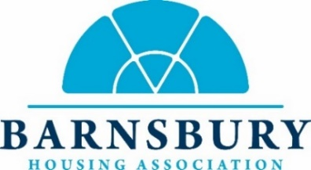
Meeting minutes for the BHA Resident’s Voice meeting
Date: September 11th 2025 at 6:30pm
Held at: 60 Morland Mews & via Teams

Residents Present: Janice Walsh (JW), Diane Gardner (DG), Franck Maze (FM), Kaaren Morris (KM)

Staff Present: Susan French (SF), Chelsey Simner (CS)

Chair: Nancy Korman (not present)

Apologies: Nancy Korman, Sila Trevor, Rachel Adelson-Kettle, Lisa Ellis, Cheryl Whittle

- Welcome and introductions.
  - All were welcomed to the meeting.
  - Action plan template was agreed for use going forward.
- Minutes of the last meeting.
  - The minutes were agreed to be an accurate record of the previous meeting held on June 26th, 2025.
- Green Grant Community Spaces
  - This item has been deferred as the member who raised it was not present.
  - KM raised the MSQ garden maintenance, which is being reviewed.
  - The issue of tree growth on the estates was raised with resulting action point 1
- Community Funday
  - A scaled down version will be held on September 20th.
  - Members of the group offered to help set up.

- Football Pitch (The Cage) closure and usage
  - The pitch has been closed for one month to determine usage.
  - Concerns were raised surrounding the closure and CS explained the reasoning behind the decision.
  - The group asked for an update on the steps going forward and the impact it will have (action point 2)
- Retrofit and Budgets for 2025/26
  - SF explained the retrofit program to the group.
  - SF proposed a ‘wishlist’ for scheme improvements for members to think about. Ideas included:
    - The external drainpipe at 303 Upper Street to be replaced. (action point 3)
    - Replacement of garage doors at Morland Mews
  - KM raised the topic of fire doors at Upper Street as no update has been given regarding the replacement of them. SF explained a new fire door programme is being put together.
- Communal cable responsibility
  - FM raised concerns over the responsibility of cable maintenance in communal areas and cost of the repair to them where other structures (e.g. plants) are beside them and may damage the cables. SF proposed it is an issue of maintenance of the garden area.
  - This will be handed over to the Head of Contracts and Compliance for review (action point 4)
- Discussion of any other resident concerns
  - A support issue with a tenant was raised. SF explained this is being managed by the HM team.
- Topics for the next meeting.
  - Updates from this meeting (action points)
  - Rent arrears and template letters
  - Service charge statements for feedback
  - Planning for Christmas
  - Group membership and scheme representatives.

The next resident panel meeting will be held 13th November 2025 at 60 Morland Mews

Minutes are published on BHA’s website:
https://barnsbury.org/get-involved/resident-voice/

For information on the panel please contact Chelsea Simner (Chelsea@barnsbury.org)

